KONDAM-KARIYANDAL; VIA-NAYUDUMANGALAM-606802; TIRUVANNAMALAI DISTRICT.
Email: pctcxavi@gmail.com; website: www.pctcability.org; Blog: pctcnews.blogspot.com

P
eople’s craft Training Center (PCTC) is completing 19 years in existence. From a humble beginning of working in 10,000 Population with polio affected children, PCTC is covering the entire Thurinchapuram Block with 120,000 populations with a comprehensive community development program. The year 2009-2010 was filled with activities. We are happy to share with you the out-come of the same.

C
ommunity Based Rehabilitation Program:
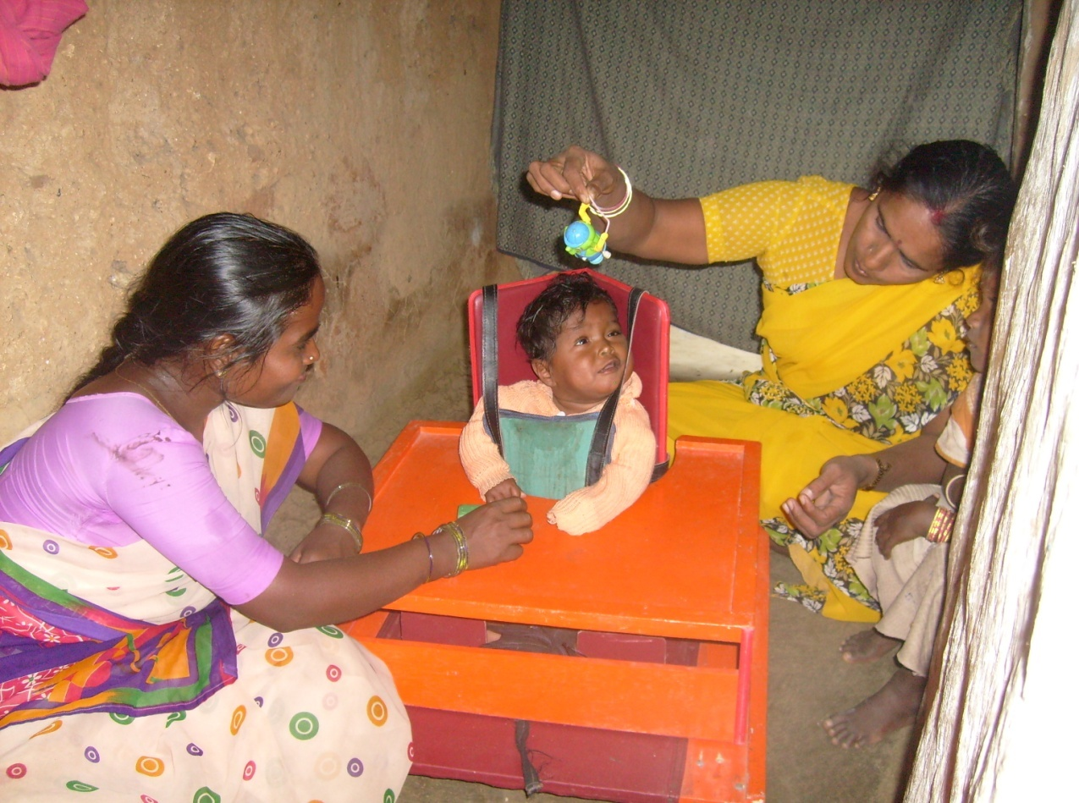
The Rehabilitation program for people with special needs is in the process of maturation. From every component of the program we are trying to find the gaps in our review meetings and to rectify the same in the process. One such initiative is our regular Village rehabilitation camps. 20 camps were conducted. And in these camps we met 612 persons and had one to one meeting, which helped the PCTC team to have better understanding of the progressing needs of the people when they are in the rehabilitation process. 712 rehabilitation needs were identified and the following needs were fulfilled.

Intervention | No. of persons
National Identity card | 137
Bus Pass | 55
Pension for persons with Disability | 4
Maintenance grant for people with multiple disability | 35
Assistive devices | 35
Educational Assistance | 94
Hearing Aid | 12
Mobility devices | 23

6 new special self help groups were formed and affiliated to the government’s poverty alleviation program. 12 children (above the age of 14) are further included in the pre vocational skills training program like envelope making, Tailoring and gardening to make them employable people when they are 18 years old. Remarkable improvements are seen in picking up the skills. The problem we were facing is the consistency of these children in a particular activity.

Ante natal and post natal care of pregnant high risk mothers was carried out regularly. Since this program is done in collaboration with Integrated Child Development Services (ICDS) of Government of Tamil Nadu, the identification of high risk mothers is not very accurate. This is a big setback for the program. More than prevention, this Program helps us in the early identification of children with disability, which enables us to give early intervention. 52 high risk mothers identified during the course of the year. Reported infant deaths were 6. Children identified with developmental delay were 4.
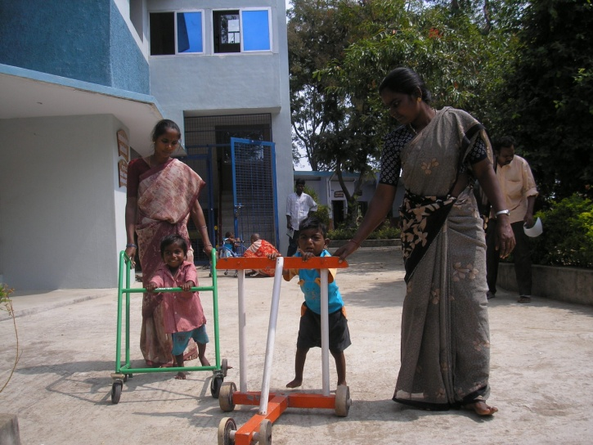

Parents along with their Children with disability visit the center regularly, to get therapeutic assistance, Special Education and medical treatment

A total no. of 36 children with special needs were regular to our day care centers in two places. A vision document in consultation with their parents was prepared for all the children. All the children’s therapy needs reassessed and assistive devices provided along with medical intervention. They received 61 different Aids and appliances. 12 children completed their parent training, as young men and women they are integrated into the community with some economic activity. These are mostly agro based economic activities as their so that they can easily acquire the skills from their parents. Depending on the ability of the child some children are directly involved in the program and others assist their parents.

Change of staff always posing a threat to the program. As the existing staff are aware of this problem there is self adjustments in the process and new person is easily inducted in the program. We have come to a realization that staff changes will be there always and be prepared to live with it.

135 children and their parents received support through our parent training program, which is a big boon to the Parents. Based on the need of the children 97 parents come to the center on a monthly basis along with their child to get continuous input on the disability of the child and how to support the child in bridging the gap in developmental mile stones. Rest of the children, who are below the age of 5 come to the center with their parents every week as they need frequent therapy and special education support.

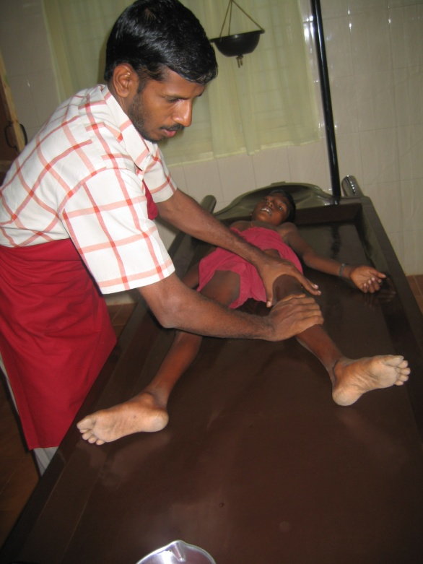

The children on a regular basis are seen by the doctor. 150 Children get medical treatment. Along with that depending on the need they are also provided with massage and steam bath, which ease their mobility

T
he self help movement.
As it has been mentioned in our earlier reports there is saturation with regard to our intervention in our micro credit program. With all these years’ constant involvement in the program the Bankers are willing to give up to 500,000 rupees to each group for any economic activity without any problem. But the productive investment of the loan is not up to the expectation. The government is working out a withdrawal strategy to make the groups more independent. The village level federations are being formed where ever we have 20 or more groups. Gradually in another 3 to four years time federations in all the Panchayats will be completed. This year 3 Panchayat level federations (PLF) are formed. They are being trained to function as a facilitating agency for all micro credit related activities in that Panchayat. PCTC restricts itself with formation of new groups, where ever needed, training them and assisting them to have the bank linkage. For older groups we function as a resource agency-as and when they need our support. We continue to motivate them about their social responsibility and involve them in Village development activity.

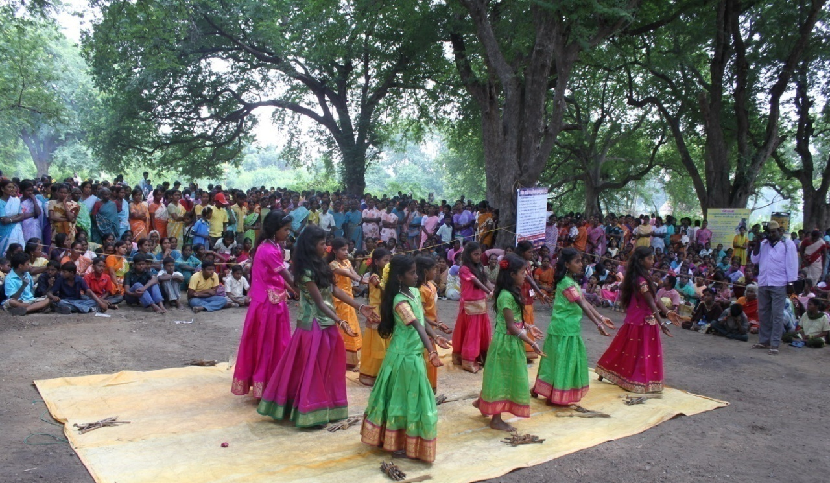

During the annual festival people with all those whom we work- the members of self help group, The children from Thulir program, adolescent people attending our pre-vocational training and all the people with disability-gather together celebrate the festival.

T
hulir –Children’s movement:

4 Thulir centers exist during the reporting period. It has been a boon to the children in the

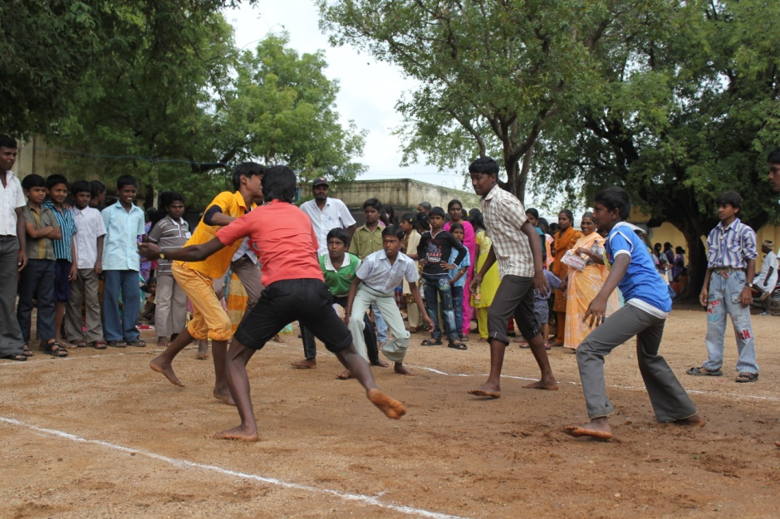

Rural sports festival conducted for the School children from Thurinchapuram Block of Tiruvannamalai District..

villages as well as to the parents- to make it a habit for the children to complete their home work every day, and to sustain their interest in co curricular activities. Thulir centers also provides opportunities to improve their skills in the use of computer and other extra curricular activities like leadership skills. In the month of May two summer camps were conducted- one on Health and another one on leadership skills. A career guidance program was organized for the 10th, 11th and 12st standard students. 35 students participated in this program.

C
hildren’s Libraries
Where ever we have Thulir centers, we have opened children’s libraries to give them the habit of reading books. These libraries were supported by Marie Jose Wouters from the royalty she had received from her book on St.Nicholas. We have one main library at the center with more than 3000 books on various subjects like arts, Science, technology, environment, health, history, traditional arts and crafts. In the village libraries we have more than 200 to 300 books which the children can borrow and read. The can also take books from the main library. We encourage children to get into the habit of reading books and every year we conduct competitions based on the books in the library. These competitions and book reviews continue to motivate them to sustain their interest in reading books.
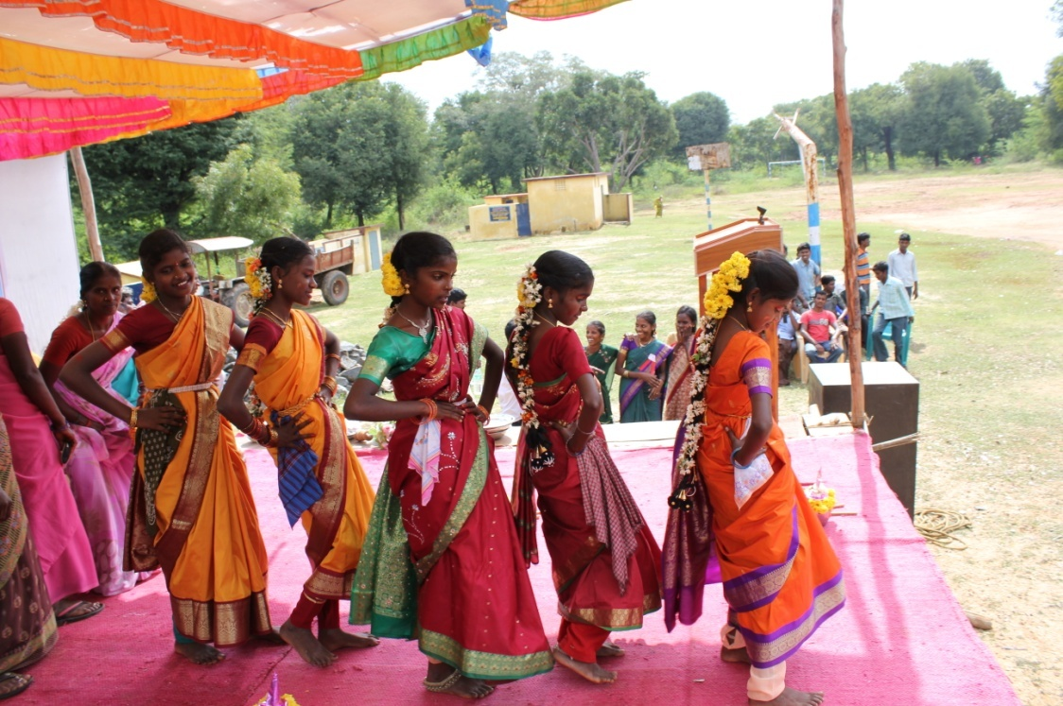

School children perform during the rural cultural festival-it is an opportunity for all the children to show cause their talents.

P
eople’s Festival 2009
This year’s people’s Festival was celebrated at Mallavadi Weekly Market campus. More than 4000 people-the members of the Self help group, children, people with Disability and the public participated in the program. All our working partners like the, the staff of Sarva Siksha Abiyan (SSA) program, The leprosy Mission (TLM), the staff from district Differently abled welfare office also participated in the program. We had the following competitions for the women:- Rangoli, Musical chair, Kabadi, and tug of war. The other competitions for the women included singing and poetry. For the School children we had Kabadi, KHO-KHO, running, jumping and quiz. For all the disabled children we conducted competitions to bring out their inner abilities. A professional group from outside was invited to traditional cultural programs like- Kolattam, Oyilattam, Thappattam, and Karagattam which was very much enjoyed by all the people present. It gave all the participants the taste of the richness of our tradition. A exhibition was organized to educate the public on the importance of prevention of disability and early identification. To promote folk arts, professional artists were invited and they performed for 3 hours. It was a day of joy for all of us as all those with whom we facilitate development process have a meaning in coming together.

C

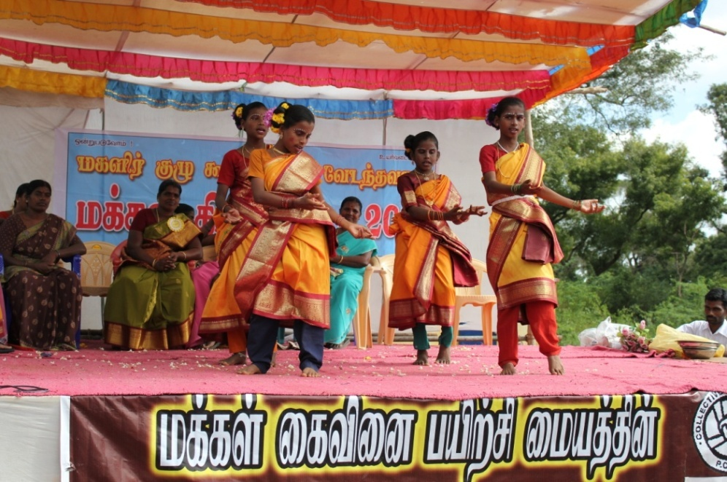

Folk dance by children during one of the village awareness program on Primary health care and the importance of early identification and early intervention for children with disability
Folk dance by children during one of the village awareness program on Primary health care and the importance of early identification and early intervention for children with disability

Community Health Program:
When we started the community health program – the idea was to promote preventive health consciousness among people and as and when they get ailments to use the native medicine. Now at every primary health center there is a medical officer specialized in native medicine and the medicine is given free of cost. We need to rethink about continuing the dispensary. The health education component is restricted to the children in the Thulir program. These children get one health education class every month and they are encouraged to develop a herbal garden in their own village. They are also taught the use of herbs for common ailments. The resident medical officer was regularly visiting these evening classes and giving classes to the children. Apart from that regular training was given to the teachers of Thulir program.

Volunteers:
We had 5 volunteers this year. They were supporting in the rehabilitation program working with the day care center, providing individual therapy for children. They were assisting the existing staff . It has helped to provide more individual support to children.

Workers Development program:

A study revealed that the migrated workers working in small industries do not have regular balanced nutritional diet. We were providing the midday meal for the factory workers, which has proved that the frequency of workers becoming sick was reduced.

For another group of workers free medical consultancy was provided on a monthly basis, which has helped the workers to prevent the avoidable sickness. More than 300 workers benefit from this program on a regular basis.
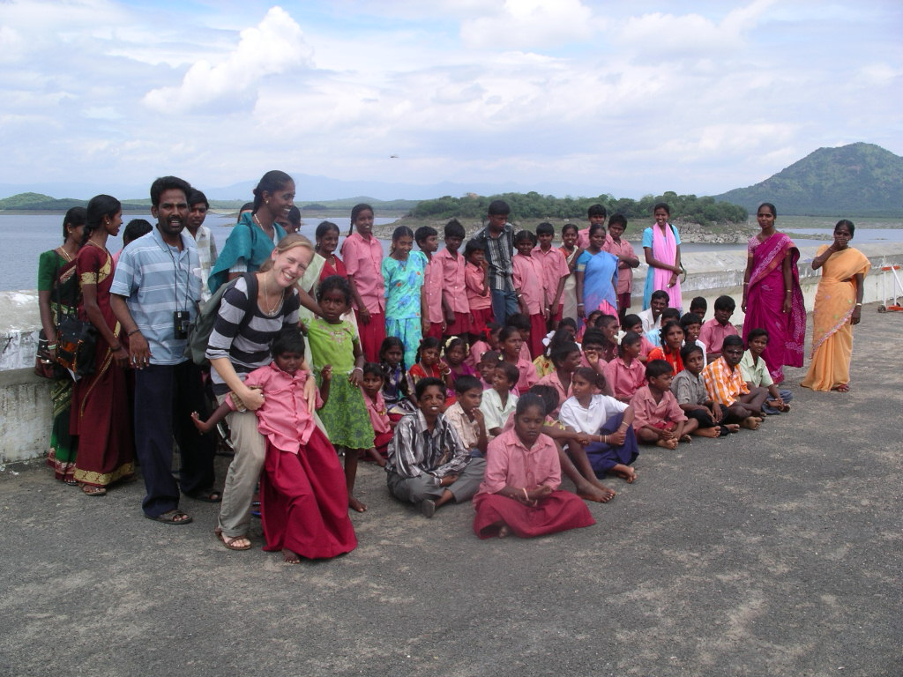

The children with disability were taken in groups for an outing- interesting places like Sathanoor Dam, which gives them an opportunity to see the outside world. This opportunity is denied for most of these children due to their disability

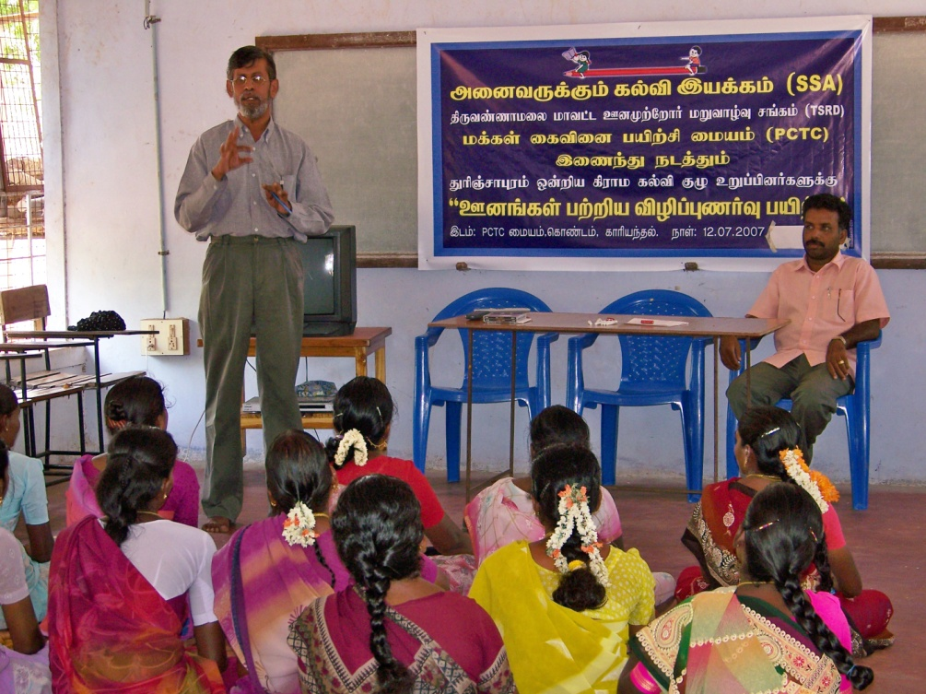

Through the Sarva Siksha Abiyan (SSA)Program training was given to the members of local bodies and the parents of the disabled children on prevention of Disability and the different Rehabilitation programs of the Government

Construction:
More number of adolescent boys and girls with special needs were coming to the center. This is due to regular rehabilitation intervention and better follow up system. We are looking into various possibilities to give them a skill and later employ them. A new building for the pre vocational training center is being constructed which will be completed next year. To make the entire campus accessible to people with disability, concreting of roads has been completed. Gardens in the campus redesigned.

Conclusion:
We all at PCTC gratefully remember all our supporters. We also thank our other collaborators-the Government departments and the NGOs. All the people of the area – the members of the self help group, people with disability, the school going children of Thulir program, deserve our appreciation for giving us an opportunity to work with them for a meaningful development.

